AI-Based PID Auto-Tuning System Using Machine Learning and AWS Cloud

1. Introduction
Proportional-Integral-Derivative (PID) controllers are widely used in industrial control systems such as temperature regulation, robotics, and manufacturing automation. These controllers rely on three parameters: proportional gain (Kp), integral gain (Ki), and derivative gain (Kd). Proper tuning of these parameters is critical for achieving stable and efficient system performance.
Traditional PID tuning methods often require manual adjustments and engineering expertise. If the parameters are not tuned correctly, the system may exhibit overshoot, oscillations, or slow response times. With advances in machine learning and cloud computing, it is now possible to develop adaptive controllers that automatically predict optimal PID gains.
This project proposes a machine learning based PID auto-tuning system that predicts PID parameters using system error signals. The model is trained using regression techniques and deployed using AWS cloud services.
Below picture shows the block diagram of PID controller.
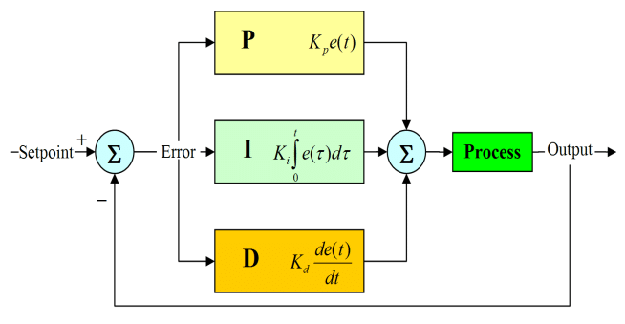
The PID control equation is:
u(t) = Kp * e(t) + Ki ∫ e(t) dt + Kd * (de(t)/dt)
Where e(t) represents the error between the desired setpoint and system output.

2. Problem Definition
Traditional PID controllers rely on fixed parameters that are tuned manually. However, industrial systems frequently operate under changing conditions such as varying loads, temperature fluctuations, or disturbances.
Key challenges include:
• Manual tuning is time consuming.
• Requires expert knowledge.
• System dynamics change over time.
• Incorrect tuning leads to instability or slow response.
Machine learning provides an opportunity to automatically learn the relationship between system state variables and optimal PID parameters. By predicting PID gains dynamically, the control system can adapt to different operating conditions.
In below picture you can see overshoot, undershoot and oscillations problem, when Kp, Ki and Kd are not set properly. It also shows an ideal repones curve. Here SP is setpoint (desired output) and PV is proportional variable (systems output)

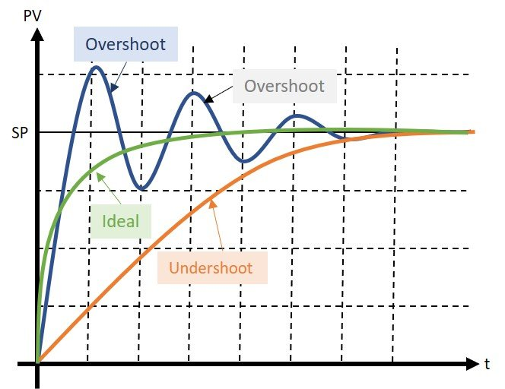

3. Proposed Solution
The proposed solution uses a machine learning regression model to predict PID parameters based on system state variables.
Input Features:
• Error (difference between setpoint and output)
• Integral of error
• Derivative of error
Model Outputs:
• Proportional Gain (Kp)
• Integral Gain (Ki)
• Derivative Gain (Kd)
The regression model learns from a dataset generated through simulation of PID system responses. Once trained, the model predicts appropriate PID gains for new system states, enabling adaptive control.

4. Cloud Platform Comparison
Three cloud platforms were evaluated for implementing the machine learning solution.
AWS:
Amazon Web Services provides SageMaker, a fully managed machine learning service that allows users to build, train, and deploy machine learning models at scale.
Google Cloud:
Google Cloud offers Vertex AI, which provides AutoML and integrated machine learning development tools.
Microsoft Azure:
Azure Machine Learning provides an enterprise-focused platform for machine learning model development and deployment.
Comparison Factors:
• Scalability
• Cost
• Ease of use
• Computational power
• Integration with other services
AWS was selected due to its strong ecosystem, scalability, and industry adoption.

5. Machine Learning Engineering Pipeline
The machine learning system follows a structured pipeline:
1. Data Generation
Synthetic data is generated to simulate PID system conditions.
2. Data Preprocessing
Data is cleaned and structured for machine learning training.
3. Feature Engineering
Important features such as error, integral error, and derivative error are selected.
4. Model Training
A regression model is trained using the dataset.
5. Model Evaluation
Model performance is evaluated using R-squared score.
6. Deployment
The model is trained and evaluated using AWS SageMaker.
7. Monitoring
The system performance can be monitored and retrained if needed.

6. Dataset Generation
Since real industrial datasets were not available, a synthetic dataset was generated using Python.
The dataset contains:
• error
• integral_error
• derivative_error
• Kp
• Ki
• Kd
These values simulate system behavior and corresponding optimal PID gains.
error | integral_error | derivative_error | Kp | Ki | Kd
3 | 10 | -1 | 0.84 | 0.15 | 0.06
2 | 7 | 0 | 0.76 | 0.11 | 0.12
-1 | -5 | -2 | 0.42 | -0.01 | 0.02

7. Model Training
A Random Forest regression model was used because it handles nonlinear relationships effectively and performs well with relatively small datasets.
The model was trained using three input features:
error
integral_error
derivative_error
The model predicts the PID gains Kp, Ki, and Kd simultaneously using multi-output regression.

8. Cloud Implementation
AWS cloud services were used to implement the machine learning pipeline.
Implementation Steps:
1. Upload dataset to Amazon S3
2. Launch AWS SageMaker notebook
3. Load dataset in Python environment
4. Train regression model
5. Evaluate model accuracy
Example prediction:
Input:
error = 3
integral_error = 10
derivative_error = -1
Output:
Kp = 0.84
Ki = 0.15
Kd = 0.06

9. AI Tuned PID Comparison
Figure below compares traditional PID with AI-tuned PID.
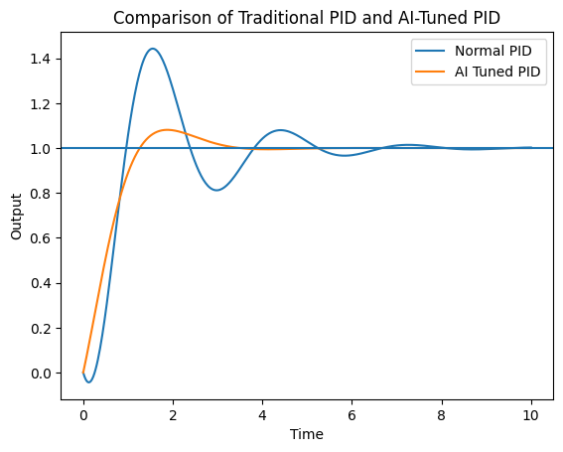

10. Conclusion
This project presented a machine learning-based approach for automatic PID tuning using AWS cloud services. The regression model predicts PID gains based on system error signals, enabling adaptive control systems.
The use of cloud computing platforms simplifies machine learning deployment and provides scalable infrastructure for training models. Future work could explore reinforcement learning techniques and real-time deployment on embedded hardware such as microcontrollers.

